

Purpose Research
Purpose Algorithm for Traffic management in LTE SDN

Advisor : Prof. Bih-Hwang Lee
Name : Ervin Kusuma Dewi
Student ID : D10507806

National Taiwan University of Science and Technology
2017

CONTENTS

TABLE iv
FIGURE v
ABSTRACT vi
CHAPTER I INTRODUCTION 1
CHAPTER II STATE OF THE ART 3
2.1. Software Defined Network (SDN) 3
2.2 OpenFlow 4
2.3 Long Term Evolution (LTE) 5
2.4. Dijkstra Algorithm 6
2.5 Study reference 7
CHAPTER III RESEARCH OBJECTIVES AND APPROACH 10
3.1. General Description of the System 10
3.2. Simulation Parameter 11
3.3. GTP Based 11
3.4. Purposes Algorithm 13
CHAPTER IV WORK PLAN 16
CHAPTER V CONCLUSION 17
REFERENCE 18

TABLE

Table 2.1. Summary of SDN or SDN LTE traffic routing. 9
Table 3.1. Experiment parameters 11

FIGURE

Figure 2.1. SDN Architecture [9] 3
Figure 2.2. OpenFlow switch main components. (Adapted from OpenNetworking Foundation, OpenFlow Switch Specification, Version 1.4.0) 4
Figure 2.3. LTE architecture [1] 5
Figure 2.4. Pseudocode Dijkstra 6
Figure 3.2. GPRS tunneling protocol 12
Figure 3.3. Propose scheme 13
Figure 3.4. Flowchart selection best route 14
Figure 3.5. Flowchart load balancing 15
Figure 4.1. Research plan 16

ABSTRACT

The growth of smart phones and tablet users followed the development of the mobile network. Challenge on mobile network in the future is to increase the throughput in support of network traffic. The number of mobile devices will surpass the total population of the word. The popular mobile packet core architecture in use today, the Long Term Evolution (LTE). The LTE (both radio and core network evolution) is now on the market. The main requirements for the new access network are high spectral efficiency, high peak data rates, short round trip time as well as flexibility in frequency and bandwidth [3GPP]
The development of the mobile market is not only LTE, but leads to 5G by adopting LTE SDN. Software Defined Networking (SDN) is enabling organization to accelerate application deployment and delivery, reducing IT costs through policy-enabled workflow automation. SDN technology enables cloud architecture by delivering automated, on demand application delivery and mobility scale.
The target issue on the core network part is traffic routing, core network sharing, and traffic management. Traffic management in LTE mobile network is the critical functionality, and any new that handles mobility events has to deliver a reliable and low-latency handover. An important one for low latency is load balancing. We will propose integration LTE SDN. In the integration we build, we also propose a new algorithm combined with Dijkstra’s algorithm to determine the shortest path. When the UEs requests to eNodeB(eNB), the eNB then goes to the Serving Gateway (S-GW). S-GW will search for the shortest route, when S-GW has found the shortest routing, serving gateway will update the information.

Keywords: LTE SDN; Traffic routing; Load balancing.

CHAPTER I
INTRODUCTION

The growth of smart phones and tablet user is followed ny the development of the mobile network. Challenge on mobile network in the future is to increase the throughput in support of network traffic. The number of mobile devices will surpass the total population of the word. Cisco [1] predicts that mobile data traffic will increase eightfold between 2015 and 2020. The popular mobile packet core architecture in use today, the Long Term Evolution (LTE).
LTE was designed by a collaboration of national and regional telecommunication standards bodies known as the Third Generation Partnership Project (3GPP) [2] and is known in full as 3GPP Long Term Evolution. The LTE (both radio and core network evolution) is now on the market. The main requirements for the new access network are high spectral efficiency, high peak data rates, short round trip time as well as flexibility in frequency and bandwidth [3GPP]. LTE and LTE-Advanced offer improved spectral efficiency and higher data rates using innovative technologies such a relay nodes and femto cells. LTE among other thing use femto cells as well as relay nodes to achieve the required increase in capacity [3].
Software Defined Networking (SDN) is enabling organization to accelerate application deployment and delivery, reducing IT costs through policy-enabled workflow automation. SDN technology enables cloud architecture by delivering automated, on demand application delivery and mobility scale [4]. To improve mobility, SDN can integration with mobile network. The integration of SDN into mobile networks to become the Software Defined Mobile Network (SDMN) process several architecture alternative, it can be integrated with the Mobility Management Entity (MME) making the controller aware of mobility events, or it can be located in the Serving/Packet Gateway (S/P-GW) to control the transport network [5].
The target issue on the core network part is traffic routing, core network sharing, and traffic management [6]. Traffic management in LTE mobile network is the critical functionality, and any new that handles mobility events has to deliver a reliable and low-latency handover. An important one for low latency is load balancing. We can use load balancer to overcome it, but the cost is quite expensive, therefore we must make cost efficient. The service based load balancing algorithm is specified resource with particular services to increase reliability and availability of the system. For both, it should consider the path as the most important thing to achieve good performance, but also maintaining path must be clearly defined.
A good algorithm for determining paths is Dijkstra because can be combined or can be extended [7]. Dijkstra’s algorithm is an avarious algorithm that tackles the briefest path issue from an offered source to the various nodes of a coordinated diagram. The technique of Dijsktra as more robust and producing a reduction within the processing time for the route calculation in case of any failure occurrence [8].
One of the most important things in to send data is route determination. The shortest path specified will affect the balancing on the network. To optimize the shortest path is using algorithm. Therefore, we will propose integration LTE SDN. In the integration we build and also propose a new algorithm combined with Dijkstra’s algorithm to determine the shortest path. When the UEs requests to eNodeB (eNB), the eNB then goes to the Serving Gateway (S-GW). S-GW will search for the shortest route, when S-GW has found the shortest routing, serving gateway will update the information.

CHAPTER II
STATE OF THE ART

This chapter explains the theoretical of the proposal. It aims to provide an overview of the system and useful to support the proposed method so that the system needs is known.

Software Defined Network (SDN)
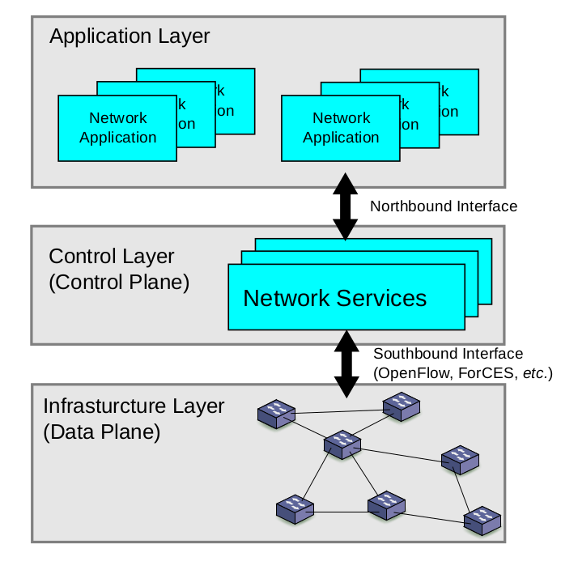
Software Defined Network (SDN) is new paradigm came from the campus and the enterprise network environments with the invention of the OpenFlow concept [5].

Figure 2.1. SDN Architecture [9]
Figure 2.1 SDN architecture consists of three layers [9]:
- The lower later is the infrastructure layer, also called data plane. Data plane consist of switch, which could be physical supporting the OpenFlow protocol. It comprises the forwarding network elements. The responsibilities of the forwarding plane are mainly data forwarding, as well as monitoring local information and gathering statistic.
- The control plane has an overview of the entire network topology and it represents the functionalities of the traditional non-SDN route being abstract in the controller. Control plane is responsible for programming and managing the forwarding plane. To that end, it makes use of the information provided by plane and defines network operation and routing. A controller translates the requirements and policies from the application plane, obtained through northbound API such as REST, to OpenFlow rules and enforces them on the data plane switches.
- The application layer contains network application that can introduce mew network features, such as security and manageability, forwarding schemes or assist the control layer in the network configuration.

OpenFlow
The OpenFlow protocol structures communication between the control and data planes of supported network devices. The OpenFlow protocol has been create to solve the problem that legacy networking protocol have created. In the software defined network (SDN) architecture, OpenFlow is the first standard communication interface defined between the controls and forwarding layers. Currently, no another standard protocol does what OpenFlow does, and it has been determined that a protocol like OpenFlow is needed to move network control out of the networking switches to logically centralized control software.
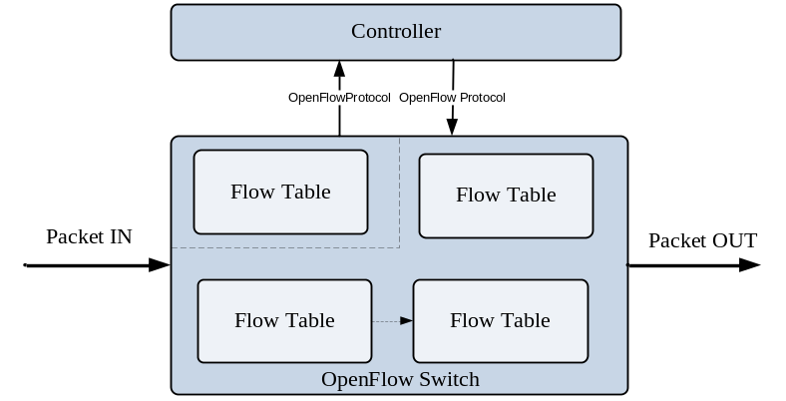
Figure 2.2. OpenFlow switch main components. (Adapted from OpenNetworking Foundation, OpenFlow Switch Specification, Version 1.4.0)
An OpenFlow switch is modeled as a group table. The group table is used to implement packet duplication output and contains group entries. Each group entry contains the group identifier, the group type, counters, and action buckets containing the actions associated with the group. There are five different types of groups:
- All: Execute actions buckets. This type can implemented for the handling of multicast and broadcast packets. Each incoming packet is replicated and processed by each bucket in the group.
- Indirect: Execute the single bucket. An indirect group is typically referenced by multiple flow entries, thereby allowing each of these entities to have a centralized action that can be easily updated.
- Select: Execute one bucket in the group. Select group is primarily designed for load balancing. Each bucket in a select group has an assigned weight, and each packet that enters the group is sent to single bucket. The bucket selection algorithm is undefined an is dependent on the switch implementation.
- Fast failover: Execute the first live bucket. In addition to this list of actions, each buckets has a watch port and/or watch group as a special parameter. The watch port/group will monitor the “liveness” or up/down status of the indicated port/group.

Long Term Evolution (LTE)
LTE was developed by The 3rd Generation Partnership Project (3GPP). The architecture of LTE known as System Architecture Evolution (SAE) describes an evolution of architecture compared to previous technology.
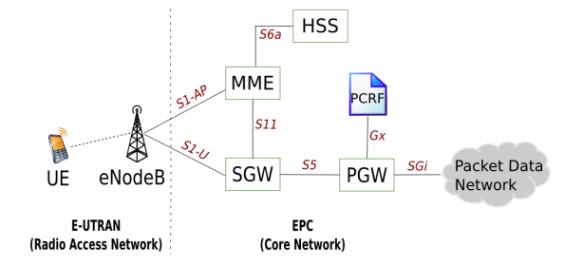
Figure 2.3. LTE architecture [1]
Figure 2.3 is The Evolved Packet Core (EPC). The main elements is:
- Home Subscriber Server (HSS)
The HSS is database that contains user-related and subscriber-related information. It also provides support functions in mobility management, call and session setup, user authentication and access authorization.
- The Serving Gateway (S- GW)
The serving gateway is the point of interconnect between the radio-side and the EPC. As its name indicates, this gateway serves the UE by routing the incoming and outgoing IP packets. It is the anchor point for the intra-LTE mobility (example in case of handover between eNodeBs) and between LTE and other 3GPP access.
- Packet Data Network Gateway (P-GW)
The PDN GW is the point of interconnect between the EPC and the external IP networks. The PDN GW routes packets to and from the PDNs. The PDN GW also performs various functions such as IP address / IP prefix allocation of policy control and charging.
- Mobile Management Entity (MME)
The MME deals with the control plane. It handles the signaling related to mobility and security for E-UTRAN access. The function of the MME is:
- Tracking area list management.
- PDN GW and Serving GW Selection.
- MME selection for handover with MME change.
- UE Reachability process.
- Bearer management functions including dedicated bearer establishment.

Dijkstra Algorithm
Dijkstra algorithm proposed in is one of the most popular solution for the shortest path problem. It finds the path with the lowest cost between a start vertex and every in the graph [10]. The algorithm function on the computation of minimum distance associated with the vertices of the network.
For all
do dist[v]
S
While
do
for all
Do if
Then
return dist

Figure 2.4. Pseudocode Dijkstra
The advantage Dijkstra algorithm is a better way to solve the problem of shortest path routing in graph. It is faster, guarantees optimality and has less computational complexibility. It is necessary to tell that only static situations were investigated. The other hand, Djikstra weakness is the fact that is does a blind search there by consuming a lot of time waste of necessary resources. Another disadvantage is that it cannot handle negative edges. This leads to acyclic graphs and most often cannot obtain the right shortest path [11]. Figure 2.4 is pseudocode Dijkstra algorithm.

Study reference
The integration SDN in LTE architecture leading a disruption in the mobile network while providing smooth migration path [6], architecture with the integration of SDN into LTE network by integrating MME with controller functionality, the result show improvement in the throughput after reducing overhead and avoiding fragmentation once GTP-U is removed from user plane between eNodeB and S/P-GW. Objective the author of [12], is to analyze the network function of the LTE EPC (Evolved Packet Core) architecture with respect to potential deployment according to the Network Function Virtualization concept and for deeper analysis, propose for architectures, in which the identified network functions are mapped differently, split between function, a middlebox and an SDN network element.
In [13] introduce and implement an algorithm to be used for proactive load balancing. This is possible by taking advantage of the statistic calculated by the OpenFlow (OF) switch and sent to the controller. The experiment result show that our application successfully balances the traffic between the nodes which preserved the high throughput and decreased latency among the new network nodes. The performance of load balancing algorithm in HetNet is investigated in [14] then show user mobility does effect the benefits of load balancing algorithm, particularly in the case of iterative algorithm. The result show that load balancing algorithm was able to provide similar benefits compared to the other two algorithm, and substantial less complex, but load balancing algorithm was superior in terms of its practically due to a minimum level of coordination and exchange of information among base stations.
A similar idea, used HetNet [15] analyze the performance of the proposed algorithms under realistic network model, and also present an analytical framework to quantity the delay incurred due to the SDN-based data processing and forwarding. Analysis and system-level simulations show that proposed load balancing algorithm significantly improves the equilibrium extent and network stability as compared to the baseline algorithms. The analyzed the performance of the proposed SDN-based partial data offloading scheme in terms of the threshold miss probability and the amount of data offloaded successfully onto Wi-Fi. Through simulations, it was shown that partial data offloading saves primary resources and decreases threshold miss probability by 20 %∼50 %. The simulation results also confirmed that SDN-based LB outperforms the baseline methods by minimizing the number of required handovers by 50 % and by balancing the loads more evenly across multiple cells.
[16] Purposes two things, which provides new benefits such as dynamic and efficient caching. Firstly, propose the integration of SDN in LTE network on disruptive approach that replaces current mobile transport with SDN based network. Second, the benefit of SDN integration to provide optimized content caching is represented. In the proposed remove GTP transport entirely and replace it with Ethernet VLANs or MPLS. In this paper also calculates load. The result shown might be applicable to any caching but the usage of SDN to remove the GTP allows that caching can be performed besides any switch of the networks.
The choice of traffic also affects load balancing. Thus optimize traffic by using the routing is also a solution to reduce network load. Traffic optimization is always a problem of finding a compromise between the load balancing and minimizing the route length [17]. If minimize through route due to overload of segment on the network, load balancing always use more connections, then distribute the load. Which can spend network resources and increase latency. The solution is proposed routing model to optimize route so can reduce network [18][19][20].
The SDN technology enable users to design their own flexible and cost efficiency load balancer. [21] Propose a load balancing algorithm for servers that are located and spread in wide area SDN networks. In the proposed algorithm, can find the nearest servers from the client by using the extended Dijkstra’s algorithm that an adapt to the topology changes. The simulation use Pyretic to implement the proposed load balancing algorithm under the Abiline network topology with the Mininet emulation tools. The simulation result show the proposed load balancing algorithm out performs others in terms of the network end to end latency and throughput.
Research using Dijkstra’s also done by [8]. A comparative analysis of Bellman Ford and Dijkstra algorithm is performed with the capability of recovering from a link failure using an alternative path. Both algorithm demonstrated effectiveness when implemented in mesh topology. The result of the comparison is a stronger Dijkstra algorithm and result in a reduction in processing time in case of a route failure.
The difference of this research with previous is in this research propose method for shortest path. When the UE sends data, it will through the controller. The controller will calculate the shortest distance of switch can be passed packet, which will reduce the load at the time of delivery. Detail comparison of this study with the previous is shown Table 2.1
Table 2.1. Summary of SDN or SDN LTE traffic routing.
Ref | Traffic  Routing | Main Component | SDN/ LTE/ LTE SDN | Algorithm/ Routing | Load Balancing
Basta, A et al [12] | GTP-based | S-GW, P-GW, NE+, SDN Controller | LTE SDN | - | -
Adalian, N et al [13] | GTP-based | S-GW, P-GW, SDN Controller | LTE SDN | -
Castro-Hernandez, D., Paranjape, R [14] | - | S-GW, P-GW, HETNET | LTE | -
Duan, X., Akhtar, A, M., Wang, X [15] | - | AP, OP Switch, Wi-Fi | SDN | -
Costa-Requena, J et al [16] | VLAN | S-GW, P-GW, SDN Controller | LTE SDN | - | -
Lepzhepekov, A., Latenko, I., Vladyoko, A [18] | - | AP, OP Switch, SDN Controller | LTE SDN | Fuzzy Logic | -
Ahmad, I et al [19] | GTP-based | S-GW, P-GW, SDN Controller | LTE SDN |  | -
Vladdyko, A et al [20] | - | OP Switch, Host, SDN Controller | SDN | Fuzzy Logic
Yahya, W., Basuki, A., Jiang J, R [21] | - | Op Switch, Host, SDN Controller | SDN | Dijkstra’s (Extended)

CHAPTER III
RESEARCH OBJECTIVES AND APPROACH

General Description of the System
The architecture adopted from traditional LTE, but the difference is the added controller because it refers to the SDN. Architecture to be built including UE, eNB, S-GW, P-GW, and MME. Figure 3.1 is a traffic flow from the UE to the internet and internet to the UE. IP packet will be forwarded via GTP tunnel from eNB to P-GW. GTP tunnel connection created when making UE service requests. In OpenFlow, each entity has a flow table so that when the packet passes it will do matching on the flow and action, if it does not match it will send the update routing to the controller.
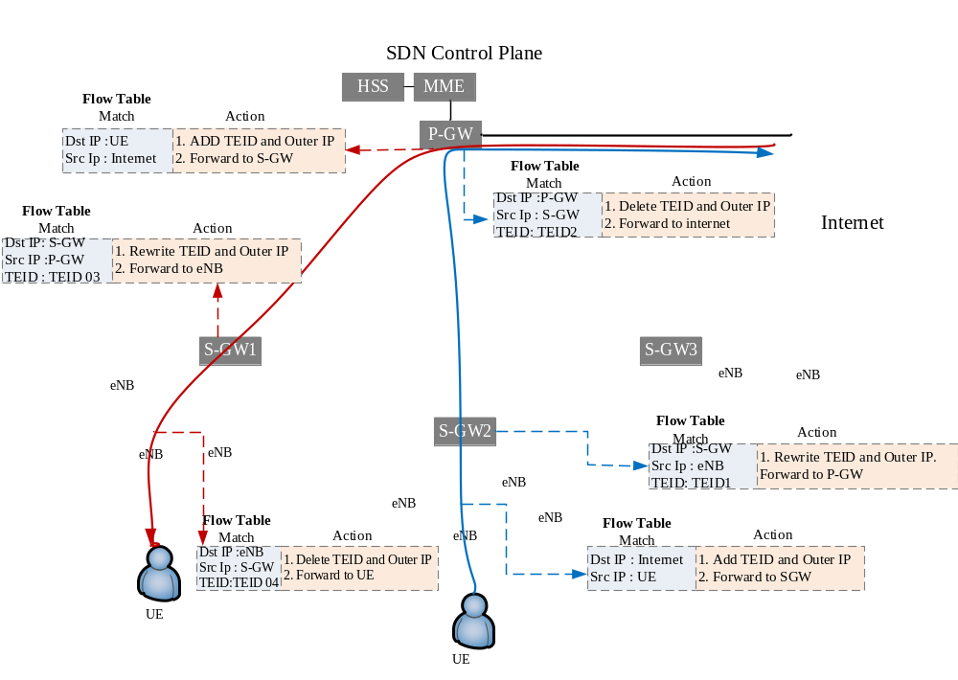 Figure 3.1.Traffic Flow
Routers for data communications can be optimized using routing updates in the SDN switch between UE related P-EGW. Route optimization can handled by SDN control. During the connection procedure, to the match on the flow table, if both conditions are appropriate, then the routing update is done. Route optimization table (ROT) will be create in the control plane, and then route updates are routed to the router between P-GW accesses. The architecture is shown in Figure 3.1. It is the traffic passed on the LTE SDN network.

Simulation Parameter
Figure 3.1 is an architecture design, there are 3 core switches, as for Evolved Packet Core (EPC) used emulator. The protocol used for data communications is User Datagram Protocol (UDP), with packet size 1520 Bytes. To simulate bandwidth consumption used two times for measurement, first test using 50 second and for second testing using 100 second. To traffic simulation in this architecture use iPerf.
In our experiment we will provide heavy and use traditional LTE as well as load balancing. Second experiment will give heavy loads, as well as using Dijkstra extend algorithm to find the shorting path, after that load balancing calculation. Both of result we analyzed and compare the results.
For controller we used Opendaylight. For simulation use open source simulator NS-3.16 with LENA LTE module.
Table 3.1. Experiment parameters
Parameter | Value
Link bandwidth | 1 Gbps
Packet Size | 1520 Bytes
UEs | 3, 5, 10
eNodeB | 9
Core Switch | 5
Evolved Packet Core (EPC) | Emulator Evolved Packet Core (EPC)
Controller | Opendaylight
Emulator | Mininet
Testing Tools | iPerf
Testing Time | 50 and 100 Second

GTP Based
In this research for traffic routing using GPRS Tunneling Protocol (GTP). GTP is an important IP/UDP based protocol used in LTE core network. It used to encapsulate user data when passing through core network and also carries bearer specific signalling traffic between various core network entities. GTP has two components :
- GTP-C, is the control part of GTP. It used for core network specific signaling (bearer activation/deletation/modification etc) in LTE/SAE/EPC networks and uses UDP as transport protocol.
- GTP-U, is used in user plane to carry user data traffic in LTE networks UDP is used as transport protocol. A data plane control used for implementing tunnels between network elements that act as routers, specifically the Serving Gateway, PDN Gateway, and wired network side of the radio bastations (eNodeB) [James Kempt dkk, 2012]
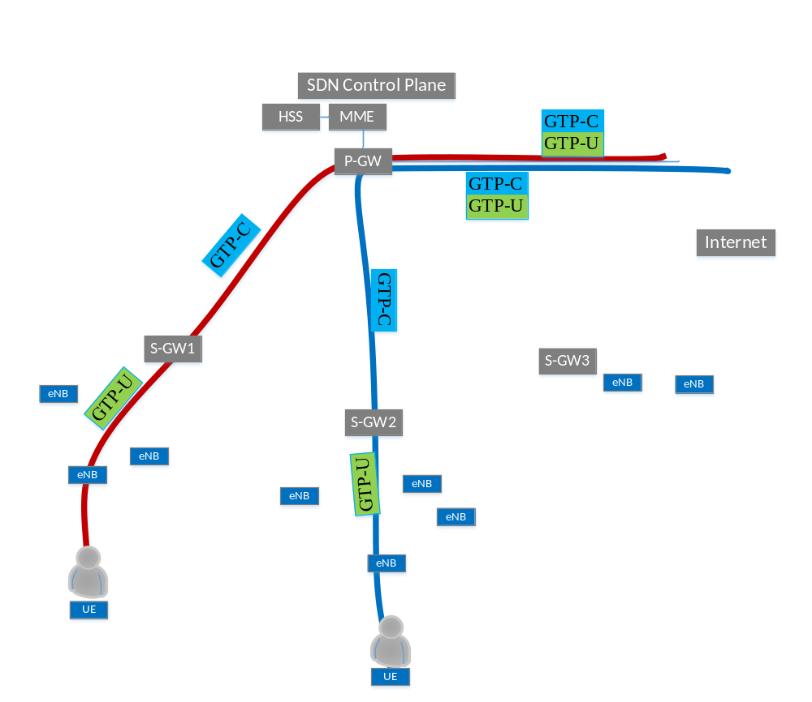
Figure 3.2. GPRS tunneling protocol

Algorithm
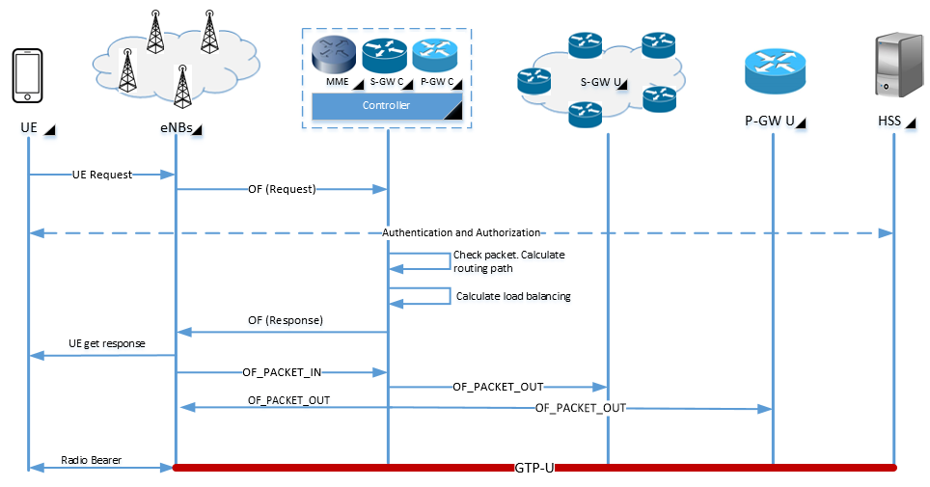
Figure 3.3. Propose scheme

The algorithm begins with UE send a request via eNB. The next step is the eNB sends a request to the controller through the Serving Gateway (S-GW). When the packet arrives at the controller then do authentication to Home Subscriber Service (HSS). After the authentication, the controller checks the packets in order to see throughput and performs the routing first, and later calcualting the load balancing. When routing path and load is lower then the controller which provides UE response via eNB. After getting the shortest routes, the packet is sent by OF_PACKET_OUT.
There are two parts to this research. First, the prupose algorithm for finding the shortes path. The original algorithm is Dijkstra’s, but will be extend to produce the best route. The reason for extend Dijkstra is the original Dijkstra’a algorithm cannot achive the same result just adding node weight into edge weight. Second, the purpose load balancing algorithm. When already getting the best route from extend Dijkstra Algorithm, then calculate load with load balancing algorithm. The goal is to get the best throughput. The details of purpose the algorithm will be explained below.
- Routing algorithm
In the propose algorithm begins by calculating the weight on each edges in the topology. Then if it has found the route then it will be calculated and taken the best value. Figure 3.4 is a flowchart of the proposed algirithm to find the best router. Below is the stages in the algorithm :
- Lookup distance in route from topology.
- Do find the distance route of the ropology
- If not find, then route discovery.
- If found, then route selection.
- Selection route or not?
- If select, then calculated the distance from source node to each node existed in the network. Calculations using extend the Dikstra Algorithm.
- Then get best route.
- If not, then end process.
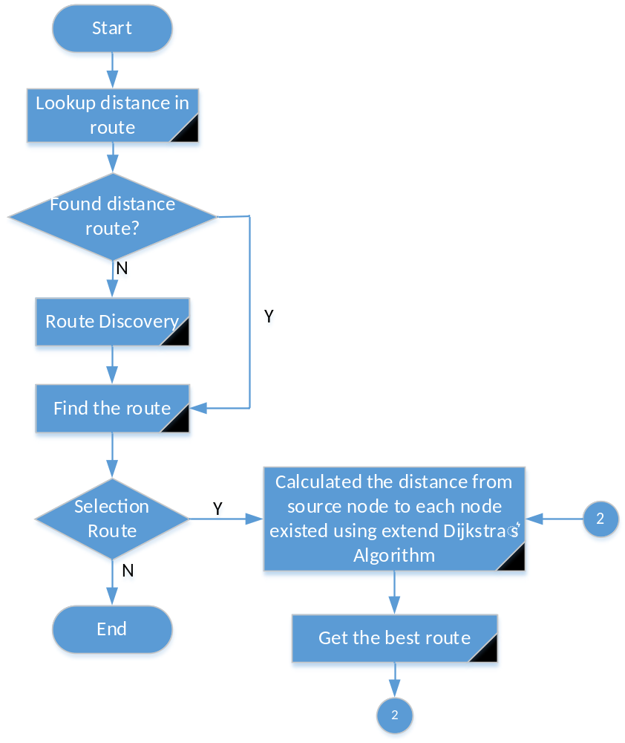
Figure 3.4. Flowchart selection best route

- Load balancing algorithm
After getting the best route, then load will be calculated using load balancing algorithm. Figure 3.5 is proposed load balancing algorithm. The following is an explanation of each step:
- Match table, because every switch controller has action and statistic.
- If not match, then switch controller request update tabel to SDN Controller.
- After getting response from SDN Controller then update.
- If match then take the best route data and data throughput from statistic table.
- Execute load balancer
- Is the resulting throughput better, if not then back in the execute on the load balancer to get a better througput.
- If the resulting throughput is better, then it is finished.
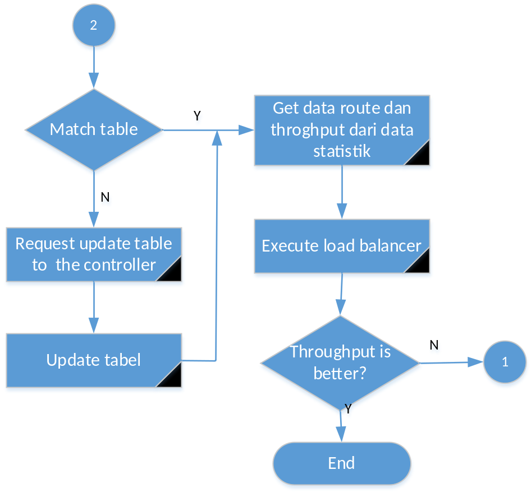
Figure 3.5. Flowchart load balancing

CHAPTER IV WORK PLAN

The study schedule is the stages of the research plan to complete the study in one time period. The content of this research plan in Figure 4.1.
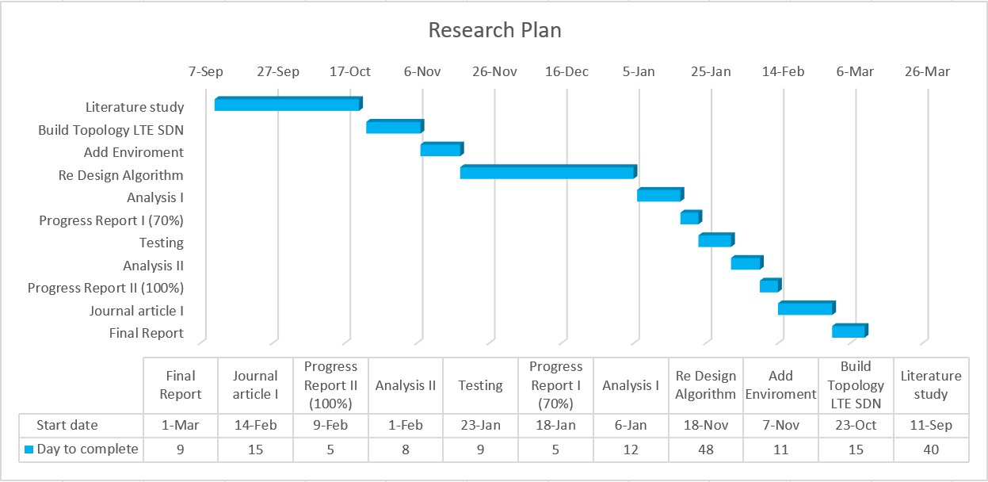
Figure 4.1. Research plan

CHAPTER V
CONCLUSION

This study is still under proposal, hopes are to propose algorithm can provide solutions to:
- Traffic routing, by searching the best route for data transmission can reduce load.
- The result of the best route will be calculated by load balancing, so with the purpose shortest path and load balancing can reduce traffic on LTE SDN.
In addition to the above expectations, the author’s hope this proposal can be accepted as a research proposal, and the future can provide benefits research.

REFERENCE

[1] Jain et al., A Comparison of SDN and NFV for Re-designing the LTE Packet Core, in: Network Function Virtualization and Software Defined Network (NFV-SDN), IEEE conference, 2016.
[2] 3rd Generation Partnership Project (2011) 3GPP. Available at: http://www.3gpp.org (accessed 10 April, 2017).
[3] Atayero, A, A., Luka, M, K., & Alatishe, A, A. Neural-Encoded Fuzzy Models for Load Balancing in 3GPP LTE. In Journal. International Journal of Applied Information System (IJAIS), Vol. 4 No. 1, 2012.
[4] Cisco, “Cisco visual networking index: Global mobile data traffic forecast update, 2015-2020”. [Online]. Available: http://www.cisco.com/c/en/us/solutions/collateral/service-provider/visual-networking-index-vni/mobile-white-paper-c11-520862.html
[5] Costa-Requena, Kantola, J, R., Santos, J, L., Software Defined Mobile Networks (SDMN): Beyond LTE Network Architecture, First Edition, John Wiley & Sons, 2015.
[6] Nguyen, V., Do, T., Kim, Y., SDN Virtualization-Based LTE Mobile Network Architecture: A Comprehensive Survey, Wireless Pers Commun 86:1401-1438, 2016.
[7] Allakany, A, M., Okumura, K., Efficient Multicasting Algorithm Using SDN, in: International Journal of Computer Science and Networking Security (IJCSNS), Vol. 17 No. 4, April 2017.
[8] Waleed, S et al., Demonstration of Single Link Failure Recovery using Bellman Ford and Dijikstra algorithm in SDN, in: Innovations in Electrical Engineering and Computational Technologies (ICIEECT), IEEE, 2017.
[9] Braum, W., Menth, M., Software-Defined Networking Using OpenFlow: Protocols, Applications and Architecture Design Choices, ISSN: 1999-5903, 2014.
[10] Naukowe, Z., A comparison between Dijkstra algorithm and simplified ant colony optimization in navigation, 29(101) pp. 25-29, 2012.
[11] Venkat, R.J., Path Finding - Dijkstra's Algorithm, available at: http://cs.indstate.edu/~rjaliparthive/dijkstras.pdf, 2014

[12] Basta, A et al., A Virtual-enabled LTE EPC Architecture: a case study for S-/P-Gateways functions, Available at: https://pdfs.semanticscholar.org/2629/99cfbfd121fc51930eb61493d35e3f6fbe7b.pdf (accessed 3 March, 2017).
[13] Adalian, N et al., Load Balancing in LTE Core Networks Using SDN, In Proc. International Multidisciplinary Conference on Engineering Technology (IMCET), 2016.
[14] Castro-Hernandez, D., Paranjape, R., Dynamic Analysis of Load Balancing Algorithm in LTE/LTE-A HetNets, in Journal, Wireless Personal Communication, 2017.
[15] Duan, X., Akhtar, A, M., Wang, X., Software-defined networking-based resource management: data offloading with load balancing in 5G HetNet, in Journal, EURASIP Journal on Wireless Communication and Networking, 2015.
[16] Costa-Requena, J et al., SDN optimized caching in LTE mobile networks, IEEE, 978-1-4799-6786-5, 2014.
[17] Khan, J.A., Alnuweiri, H.M., A fuzzy constraint-based routing algorithm for traffic engineering, in: Global Telecommunications Conference, GLOBECOM vol. 3, pp. 1366–1372, IEEE, 2004
[18] Lepzhepekov, A., Latenko, I., Vladyoko, A., Software-Defined Routing in Convergent LTE/WiFi Network, in: Young Researchers in Electrical and Electronic (ElConRus), IEEE, 2017
[19] Ahmad, I et al., New Concept for traffic, Resource and Mobility Management in Software-Defined Mobile Networks, in: 12th Annual Conference on Wireless On-demand Network System and Services (WONS), 2016.
[20] Vladdyko, A et al., Fuzzy Model of Dynamic Traffic Management in Software-Defined Mobile Networks. In: International Conference on Next Generation Wired/Wireless Networking, Springer International Publishing, 2016
[21] Yahya, W., Basuki, A., Jiang J, R., The extended Dijkstra’s based load balancing for openflow network, in: Intentional Journal of Electrical and Computer Engineering (IJECE), 2015.

